**Preparation for Assessment : Science Inquiry - Biotechnological Techniques**

**Activity** Amino acid sequencing

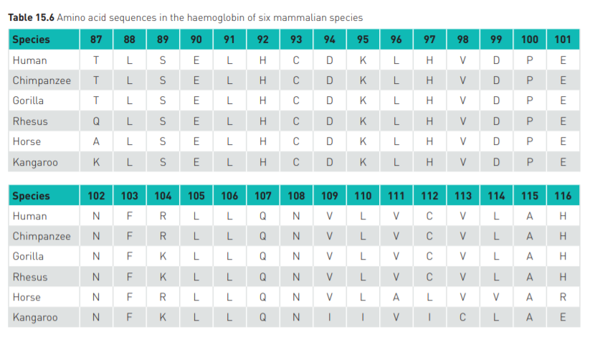

What to do

**1** Examine Table 15.6 above, and count the number of differences in the amino acid sequences for the pairings of species shown in the table below:

|  |  |
| --- | --- |
| **Species comparison** | **Number of differences in the amino acid sequences of haemoglobin** |
| Human and chimpanzee |  |
| Human and gorilla |  |
| Chimpanzee and gorilla |  |
| Human and rhesus monkey |  |
| Chimpanzee and rhesus monkey |  |
| Gorilla and rhesus monkey |  |
| Human and horse |  |
| Human and kangaroo |  |

1. Using only the data from this section of the haemoglobin molecule, rank the species in order from the one closest to humans to the one most distant.

## Studying your data

1. Based on this segment of the haemoglobin molecule, which species of mammal appears to be the most closely related to humans?

1. Which animal appears to be the least closely related to humans?
2. Which of the other pairs of species show close relationships?
3. These sequences of amino acids are generally very similar but not identical. If these species were all descended from a common ancestor how would the changes in the sequences of the different species have come about?
4. Do you think the differences in the amino acid sequences between the species would affect the function of haemoglobin?

## In summary

Using the information from the sequences of amino acids in haemoglobin, describe the evolutionary relationships between the species.

………………………………………………………………………………………………………

………………………………………………………………………………………………………

………………………………………………………………………………………………………

………………………………………………………………………………………………………

………………………………………………………………………………………………………

……………………………………………………………………………………………………….

………………………………………………………………………………………………………

………………………………………………………………………………………………………

………………………………………………………………………………………………………

………………………………………………………………………………………………………

………………………………………………………………………………………………………

……………………………………………………………………………………………………….

………………………………………………………………………………………………………

………………………………………………………………………………………………………

………………………………………………………………………………………………………

………………………………………………………………………………………………………

………………………………………………………………………………………………………

……………………………………………………………………………………………………….